Nurtai Maksat

We can see how a simple SVM algorithm can be used to find the solution boundary for linearly shared data. However, in the case of nonlinearly shared data, for example, shown in FIG. 1, a straight line cannot be used as a solution boundary.

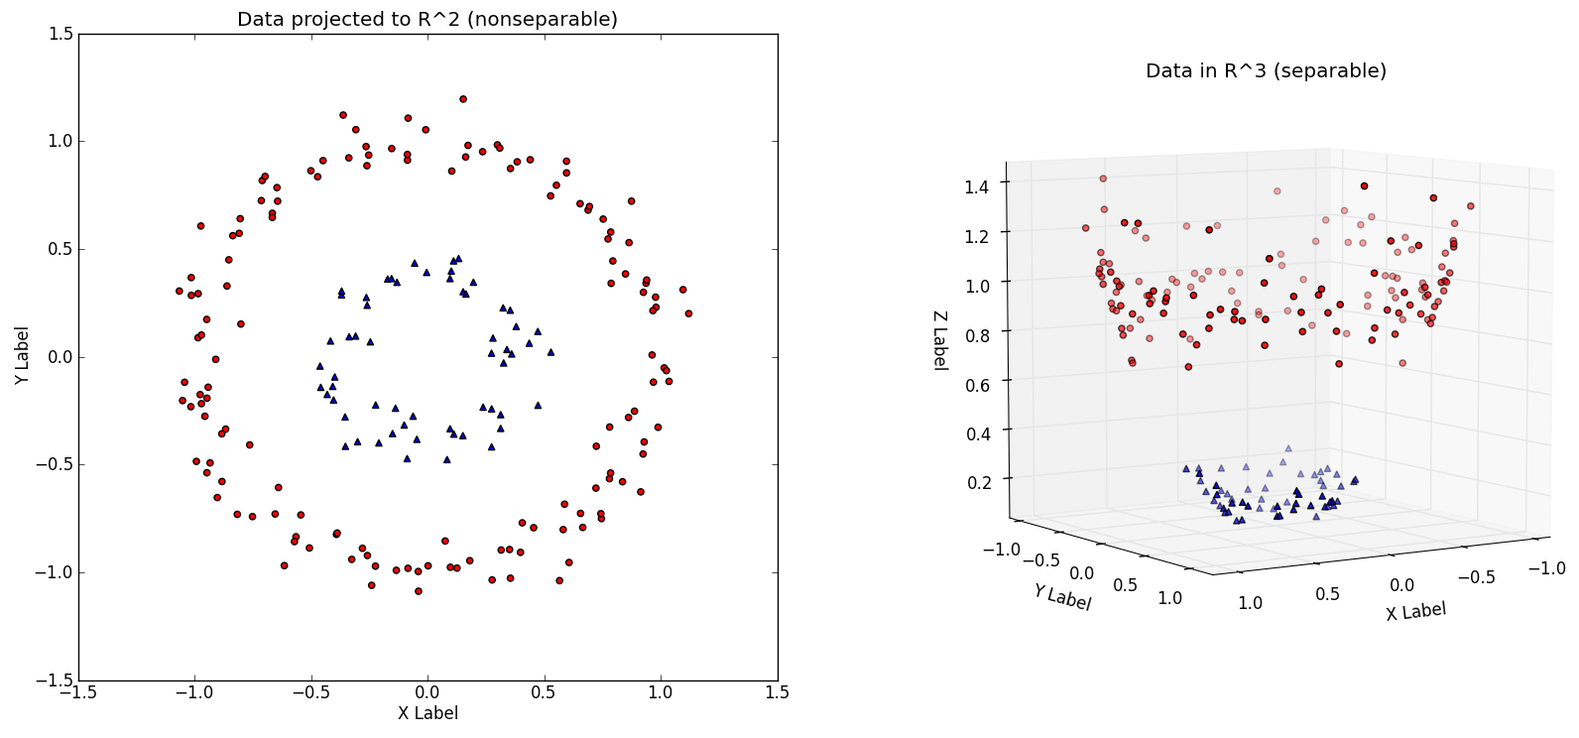

Fig. 1 - Non-linearly Data

In the case of non-linear data, the simple SVM algorithm cannot be used. Rather, we need to use a modified version of SVM, called Kernel SVM.

In the case of a simple SVM, we used “linear” as the value for the kernel parameter. However, for the SVM kernel, we can use Gaussian, polynomial, sigmoidal. I will use polynomial, Gaussian, and sigmoid cores to see which one works best for our problem.

1. **Polynomial Kernel (poly with degree=1)**

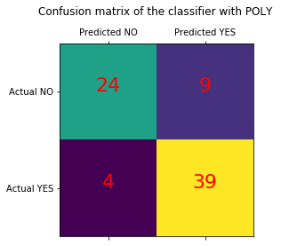

1. **Gaussian Kernel (rbf)**

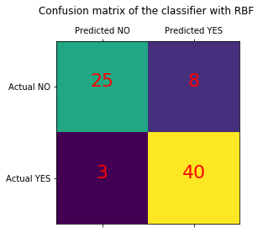

1. **Sigmoid Kernel**

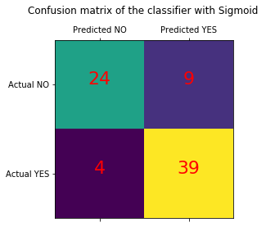

As you can see in my case "rbf" was the best, although other parameters did not lag far behind. If we compare in other cases the performance of different types of kernel, we can clearly see that the sigmoid kernel performs the worst. This is due to the fact that the sigmoid function returns two values: 0 and 1, so it is more suitable for problems of binary classification. Among the kernel of the Gauss and polynomial kernel, we see that the Gaussian kernel reached an almost perfect prediction, while the polynomial kernel incorrectly classified instances. Therefore, the Gaussian kernel performed slightly better. However, there is no hard and fast rule regarding which kernel works best in each scenario. It's all about testing all the kernels and choosing one of the best results in your test dataset.